4th Week Assignment TODO
1: Follow Folder Pattern
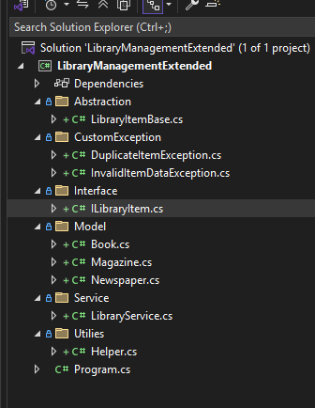
2: Create Interface
Your existing LibrarySystem has Item class where you declared properites like title, publisher, publicationYear…..
Now you add all these into Interface. You can add other properties as well beyond what has been asked in the assignment
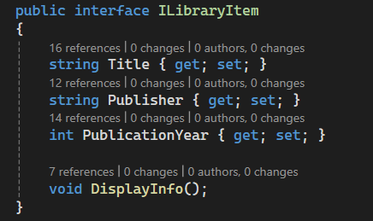
3: Create abstract class
Now create abstract class LibraryItemBase which implements Interface. But make sure you have all those public properties as well similar to existing LibraryManagementSystem.
public properties must have validation
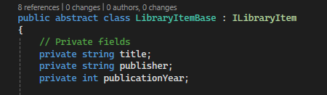
Also make sure project must have customExceptions
-> DuplicateItemException
-> InvalidItemDataException
4: All the classes Book, Magazine and Newspaper must be within Model folder and these classes need to implement abstract class LibraryItemBase
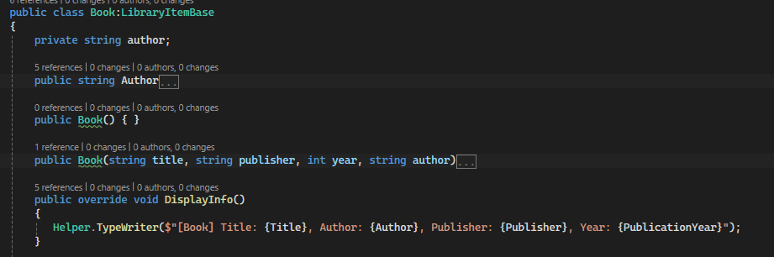
5: Create Service folder and create a class LibraryService which most of you already have in your existing project.
Within add function, it is checking if List has any item or not. Now since you are dealing with File so, check if file has any item. And check for duplicate accordingly.
Create private property CheckForDuplicate and IsDuplicate as in the screenshot
Within IsDuplicate function, code works perfectly, but you need to refactor the code.
Tips to refactor code,
private bool IsDuplicate(ILibraryItem existingItem, ILibraryItem newItem)
- This function will take existingItem(these are coming from foreach loop) and newItem(these are coming from user input from the console).
- We have three different types of item (book, magazine and newspaper) which are different from each other so figure out a way to check if exising and newItem are of same type and return false immediately.
- Check for base properties like Title, Publisher and PublicationYear which are common for each items.
- Check for Item specific property like
Book -> author
Magazine -> IssueNumber
NewsPaper -> Editor
This method will shorten the code and refactor.
In the realworld, most of the time, we need to refactor existing code eventhough its working.
Here is the screenshot what to do
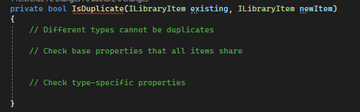

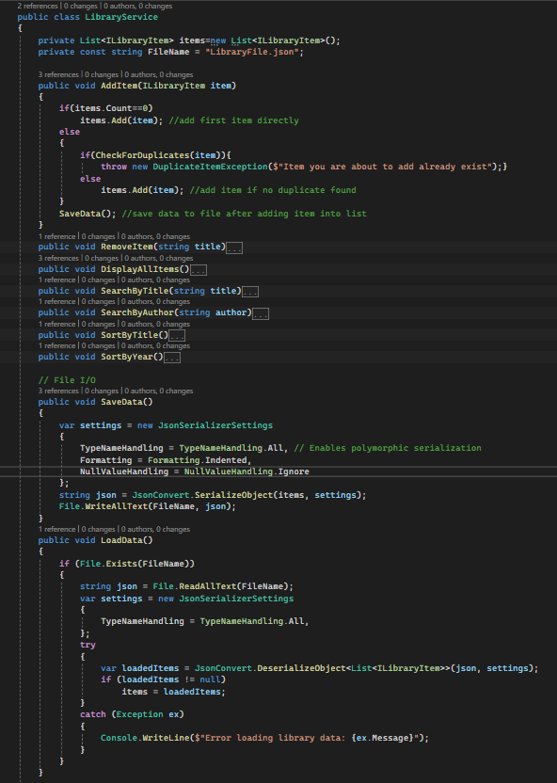
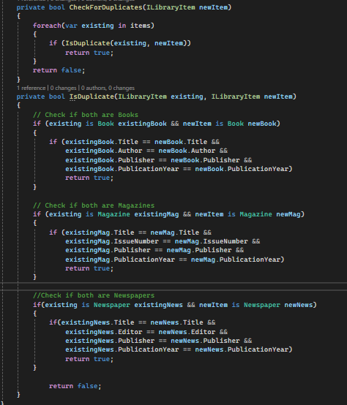

6: And Finally Program.cs file should be similar to this
